Ham radio operators continue to support county
Story by John Larson, El Defensor Chieftain | May 18, 2023
In times of disaster or an emergency at any level, the Socorro County Office of Emergency Services has traditionally been able to rely on being assisted by a cadre of local amateur radio volunteers, members of the Socorro Amateur Radio Association (SARA).
A Memorandum of Agreement between Socorro County and SARA was renewed at a county commission meeting in April to keep that association going. The MOA states that “the County recognizes that amateur radio operators provide essential services in times of emergencies and also support the community in a variety of other ways. This includes the activities of individuals and groups within SARA and also of the Amateur Radio Emergency Service, an activity sponsored by the American Radio Relay League.”
The MOA notes that “amateur” in this context means radio operators who are not paid for their efforts, and in no way implies any lack of credentials or abilities.
The MOA states that since SARA members volunteer their time, resources and skills to aid the County’s Office of Emergency Services, “the County desires to utilize such skills to help in emergencies in order to protect the health, safety and welfare of the County’s inhabitants.”
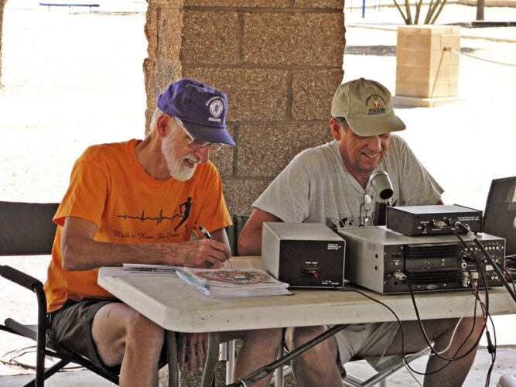
The Socorro Amateur Radio Association conducts events such as a ham radio field day.
File photo
In exchange for the volunteer services, Socorro County provides SARA and ARES facilities for meetings, equipment storage, and other activities, including regular on-air network practice, training, and recreational operation.
Jim Lommen, president of SARA, said meetings occur in the Emergency Management Office conference room on the second Wednesday of each month. Usually, 10 o 12 members attend.
He said the group welcomes anyone interested in becoming an amateur radio operator.
To that end, SARA member Jon Spargo runs a class at Cottonwood Valley Charter School to help students learn about amateur radio and prepare for their FFC license.
“We feel it’s important to encourage young people to learn what it’s all about and hopefully carry that interest into their adult lives,” Spargo said. “We just finished a class. Several of the class members got their license, and the other five will take their test again later this summer.”
But not all of those receiving their FCC amateur radio licenses were students.
“The county’s Emergency Manager, Gail Tripp passed her FCC exam and received her Technician Class license from the FCC,” Spargo said. “Fire Marshal Jerry Wheeler also got this ham radio license, and the father-son duo, James and Matthew Price, upgraded their licenses by passing the General Class FCC license exam.”
According to the Federal Communications Commission, “licenses to operate amateur stations for personal use are granted to individuals of any age once they demonstrate an understanding of both pertinent FCC regulations and knowledge of radio station operation and safety considerations.”
“At well over 100 licensees, Socorro has one of the highest per capita ham radio operators of any town, anywhere,” Spargo said.
SARA’s website points out that for more than 100 years, Amateur Radio – also called ham radio – has allowed people from all walks of life to experiment with electronics and communications techniques and provide a free public service to their communities during a disaster or emergency.
“In today’s electronic do-it-yourself environment, ham radio remains one of the best ways for people to learn about electronics, physics, meteorology, and numerous other scientific disciplines,” Spargo said. “It’s the original social media.”
Lommen noted that after a COVID-caused hiatus, Hamfest returns to the Fire Academy on October 21.

