How Far Can I Talk with My Radio?
Recently, a work colleague became interested in ham radio for emergency preparation purposes. Knowing that I am an enthusiastic ham operator, he innocently wandered into my sparsely decorated, dull beige Dilbert cube and asked me with earnest curiosity, “So, how far can you talk with one of those handheld ham radios?”
Smiling slightly, I imagined my dull beige cube rapidly morphing into a sticky, silky, threaded web; the individual strands gently curving in the manner of radio waveforms, intersecting grid-like, and offering no way out for uninformed prey. This prime opportunity to suspend my spreadsheet squinting drudgery could not be wasted with a brief, simple answer. Quickly, before he could strategize escape, I nodded, pointed to the cube’s solitary visitor’s chair, and ensnared him with a knowledgeable, definitive, and unambiguous “It depends.”
If I play this right, I thought, I could talk ham radio until lunch and get my distal vision back to at least 20/40!
“Well, just a ballpark idea is all I’m –” Uh oh.
“It’s just not that simple,” I cut in. “Let’s back up just a bit and talk some theory, then we’ll get to the practical considerations and those dependencies. That way you’ll have all the basic information to consider many different scenarios for yourself. OK?” He eyed me hesitantly, but then shrugged in resignation of his entrapment. Whew, that was close. I could have lost him there, before we even got started!
I began painting the landscape for him, beginning with the radio horizon on a whimsical smooth, bald world.
The radio horizon is like the visual horizon: It is the distance to a point where the signals are effectively blocked by the curvature of the earth. With the visual horizon the light waves from “over the horizon” are blocked by the curvature and cannot reach your eyes. With radio, of course, it is the radio transmissions that are blocked and never reach a receiver. Due to several combined effects of atmosphere and environment, the radio horizon is a bit further than the “line of sight” visual horizon. In other words, radio waves bend slightly and reach further around the curvature of earth than do light waves.
If we imagine the earth with a perfectly smooth surface – no hills, no valleys, no buildings and no trees – we can use some pretty simple geometry to determine a calculation of the visual horizon for a given viewing height above the ground. A higher vantage point means a more distant horizon, both visually and with radio signals. To calculate the radio horizon an adjustment factor of about 15% more than the visual horizon case is added in this formula.
Let H be the height of your antenna in feet above the ground on the smooth earth, and let D be the distance to the radio horizon in miles. The radio horizon is calculated as:
D = √H x 1.415
For example, suppose you are just under six feet tall, and your HT radio antenna extends up to precisely six feet when you raise the HT to your mouth to transmit. When you transmit on our theoretical bald earth you get:
D = √6 x 1.415, or
D = 3.47 miles
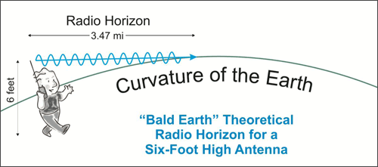
So, on our perfect geometric planet your radio waves begin to bump into the curvature of the earth about 3½ miles away. However, that’s not the end of the matter! The whole point of transmitting is to be received, right? We must consider that another operator with another antenna at some height above the ground is going to receive your signals.
Let’s say the other operator also has an antenna six feet high. Your radio signal will just barely scrape the ground at 3.47 miles away. But the signals are like an expanding sphere, like an ever inflating balloon, and not just a line. So the part of the signal sphere that clears the earth at that horizon point and keeps expanding away from the ground can still be received by another antenna that is elevated above the earth, effectively sticking up through the radio shadow of the horizon and into the rising signals, like the image below. It is only when the transmitted signals also clear the height of a potential receiving antenna that the horizon is imposed.
In order to determine total distance that a transmission may be received by two elevated antennas, we must add together the radio horizon distance of both antennas. In our scenario of two separated operators, each with antennas at six feet above the ground, both stations will have a radio horizon of 3. 47 miles. Adding them together yields 6.94 miles, or just about seven miles, rounding up.
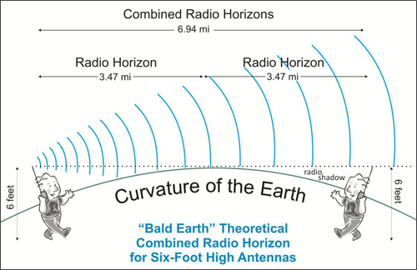
If either, or both, antennas are higher, the sum of their two radio horizon distances will increase. To illustrate the point, let’s consider the repeater station on top of Pikes Peak, Colorado, at about 14,110 feet high. The other station is our six foot high HT radio down near sea level. Here’s how the numbers work out:
Pikes Peak D = √14,110 x 1.415 = 168 miles
HT Station D = √6 x 1.415 = 3.47 miles
The sum of the two is about 171.5 miles! So, why can’t I activate the Pikes Peak repeater with my HT from the west side of Kansas? While in our bald, perfect world the radio horizon may allow for your HT signals to reach from Kansas to Pikes Peak in central Colorado, that ever expanding spherical waveform gets weaker and weaker as it expands into the distance. For every doubling of the distance traveled the power of the signal is reduced by a factor of four. There is just not much remaining of a 5 watt HT signal after 171 miles. However, if you bumped up the transmit power substantially, you might be able to hit the repeater from the Sunflower State.
(Note: Keep in mind that in our real world, not the smooth, bald, whimsical one, western Kansas is almost 4000 feet above sea level. So the true antenna height difference with Pikes Peak is only a little over 10,000 feet. That adjustment of reality makes Kansas a real stretch for reaching Pikes Peak.)
Your HT’s power will make communications quite feasible over impressive distances if you are within combined radio horizon with the other station. For example, with my 5 watt HT I can activate and readily communicate via a mountaintop repeater station that resides at 11,800 feet over 45 miles distant from my home. Using a mobile-base station at 20 watts with an antenna inside my attic I frequently get excellent signal reports from a high repeater station in Boulder, Colorado, over 60 miles straight line distance. With my base station and 100 watts I have communicated with a Fort Collins, Colorado, repeater at just over 100 miles away, again on a high mountaintop. (All isometric antennas – radiating equally in all directions with no directional antenna gain.)
Of course, the earth is not like a bald head. We must contend with mountains and hills, valleys and hollows. And trees, buildings, fences, and myriad other “things” that get in the way of our radio signals as they struggle to perform their duty and carry our messages out to the world. Clearly, if you are transmitting from down in a canyon your signals will go straight up, but not laterally out to other receivers beyond the canyon walls. A low-lying position in rolling terrain, while not as severe as the canyon, will reduce your radio horizon. High-rise buildings in a metropolitan setting are almost like canyon walls and may severely attenuate your signals, but a metal chain link fence can also reduce the strength of your signals beyond. Even the foliage takes a toll, if only a tiny one, with UHF signals.
The point to take away from all this is that getting your antenna higher will improve your radio horizon, and boosting power will help keep the signal strong enough to be received by another station at a distance within the combined radio horizons. Of course, always keep in mind the FCC rules that operators should use the minimum power necessary for the communication, and don’t overuse power just because you have it!
So, the answer to my colleague’s question remains, “It depends.” At least now he knows some of what it depends upon for VHF and UHF signals and can consider specific situations for himself. The ionosphere “skip” of the HF bands is a whole other matter with a very different set of dependencies!
But, look at that… Time for lunch. We can talk HF another time. Hungry?

